Adswood Primary School Newsletter

Newsletter March 2024
Dear Parents/Carers,

Thursday 7th March is WORLD BOOK DAY! Please send your child in a character costume, an author or anything related to a book for the day!

Reading at Adswood Primary – we continue to promote reading for all through school. This is one of our school improvement priorities.
Reading with your child at home is vitally important to ensure that they are developing their understanding of the world, improving their reading skills, whilst also promoting a love of reading.
Sometimes it can be hard to find the time, but research suggests that reading aloud to children or children reading aloud to an adult, even if only for a short time each day, develops their language skills, as well as enhancing their love of literature.
The information below contains ideas and questions that you might use to support your child’s reading at home.

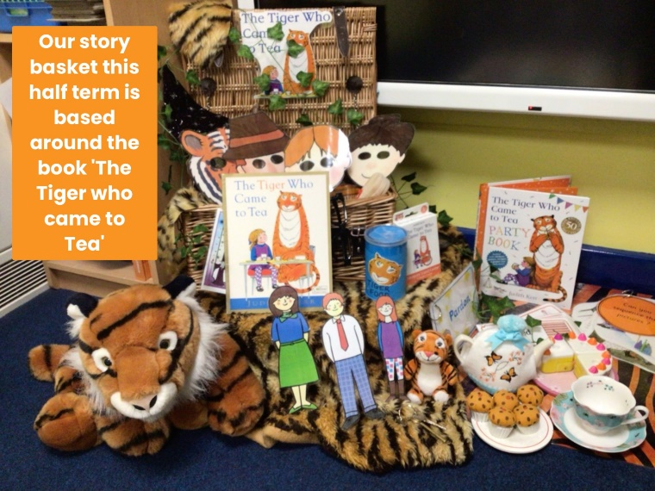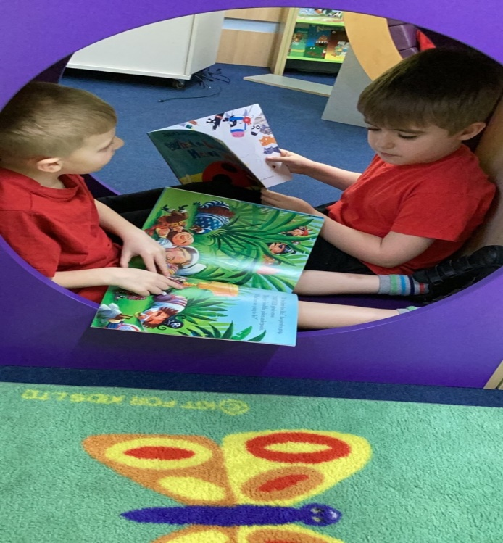
Why is reading so important?
• Books provide good models of language.
• Reading develops the imagination.
• Exploring a variety of texts develops our pupils’ vocabulary.
• Reading helps to explore life beyond a child’s immediate experiences.
• Reading can help a child to develop their own story telling skills.
How can you support your child with their reading at home?
• Ensure your child reads at least FIVE times a week, and sign their reading record when they have read.
• Children enjoy hearing the same stories, however it is useful to explore a wide range of books. Children often like the repetition of familiar stories. These are fine but try to explore other stories too.
• When looking at a book, decide whether you are going to read the story or talk about the book.
• When you read, encourage the child to sit and listen. It is good for a child to hear a story read to them slightly above their reading ability, to develop their vocabulary and understanding of more advanced texts.
• When your child reads, check that he/she has understood the story. When learning to read it is sometimes hard to work out what each word says and means. Once your child gets to the end of a difficult page ask them to read it again or you could read it so they can understand it. Check your child’s understanding at the end by asking your child to tell you about the story by summarising key events.
• Ask your child if there is anything in the story they did not understand.
• Encourage your child to talk about the story and give reasons why they liked/disliked it.
• Repeat back words and sentences they use correctly so your child hears good examples. Sometimes add one more detail or an idea to develop his/her language acquisition.
• Check that your child knows what the words mean. Explain difficult words and show your child how to use words by giving examples of sentences.
• Exploring and using vocabulary. Ask your child to write down any new words they come across and try to use them in a sentence.
• Encourage your child to sequence the ideas and events in the story in the correct order.
• Encourage your child to describe objects and people, adding details and extra information. This will help to develop your child’s vocabulary.
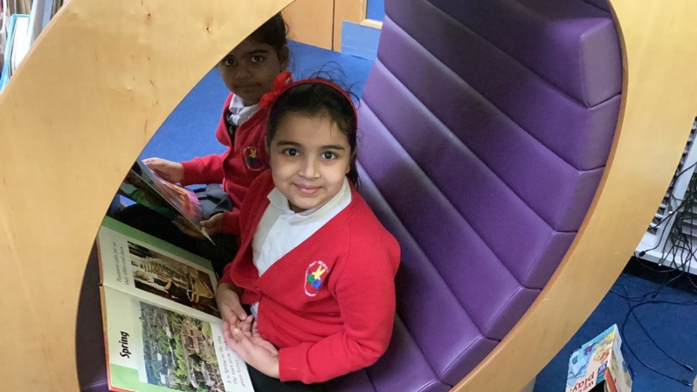
What types of questions should I be asking my child? Asking questions is really important to developing understanding and vocabulary. Ask a few questions at different points of the book; however, try to let your child lead the conversation about the book.
If you have any questions about reading, please contact your child’s class team or the reading leads in school Miss McFayden and Mrs Ayers.

Foundation 5!- We recognise the need to prepare our children for transition to high school particularly in Year 5 and Year 6. We launched our unique ‘Foundation 5’ afternoons in September 2022 and they continue to be extremely successful. Children from those classes move across a number of lessons over three afternoons. They are taught Music (Miss Hodgkiss) , Beliefs and Values (Mrs Lennon), Languages (Miss Holland) , PE(Mr Smith) and Computing (Mrs Ayers) by the teachers. This prepares our children for transition, forming relationships with different staff, becoming familiar with different styles of teaching and being taught by specialist teachers in the chosen subject. We ask our children about the impact this has had on their learning and the feedback suggests that they would like to continue with this approach as it makes them ‘high school ready’! A great incentive, unique to our school!

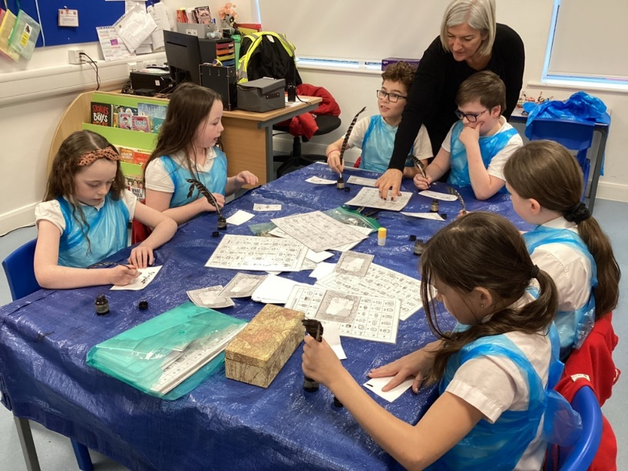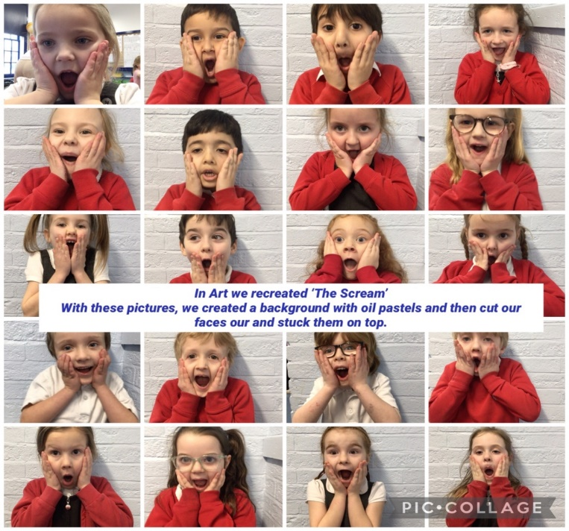

Attendance Matters!
The National target for attendance in all primary schools is 95%, Adswood Primary are currently 92.7%. We have noted an increase in attendance figures across school since last term and hope we can continue to work together to make sure children attend school each day.
Seesaw App
We communicate all messages, children’s learning, key events via our seesaw app. Feedback from families is that you enjoy receiving notifications of children’s learning each day/week. The seesaw app enables others to see the learning that takes place throughout school. It really is a pleasure to look at these each week.
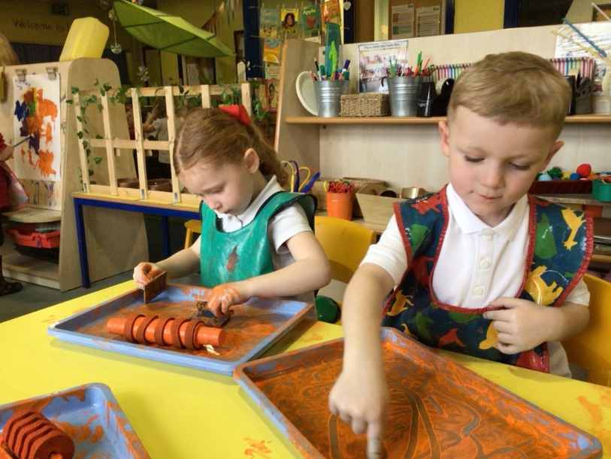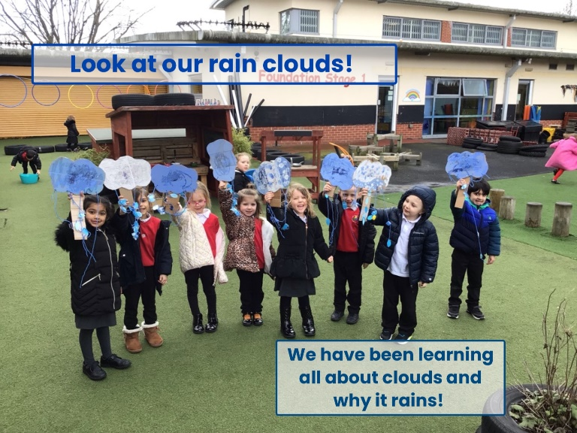
Dates coming up –

- Visitors from ‘The Landing’ to work with Year 5 Mrs Ayers class next week!
- Year 6 Kingswood Residential – Monday 4th March – 6th March
- Monday 11th March at 6pm – Year 4 to perform at the ‘Disney - Be our Guest’ event at the Town Hall
- 14th March – Nursery afternoon Tea Party for families
- 15th March – Red Nose Day! Wear something red for the day – a bobble, a sock, a jumper – please donate £1 to the charity via ParentPay
- Year 4 All Hallows Church - Easter Trail
- Thursday 21st March – Willow Garden – Stay and Play for Reception families
- Friday 22nd March – Easter Show for Key Stage 2
- 27th March - 3.15-6.15pm Parents/Carer Meetings from Nursery – Year 5

- School closes on Thursday 28th March and will reopen on Tuesday 16th April (Inset day Monday 15th April for staff training)

If you have any queries or questions please do not hesitate to contact school.
Best wishes for the term ahead.

M Smart and the Adswood Team

