Travel Plan

Adswood Primary School

Ratified by Governing Body on: | 23rd January 2023
M. Smart  Head Teacher | J Dancy  Chair of Governors
Governing Body Review Date: | January 2025

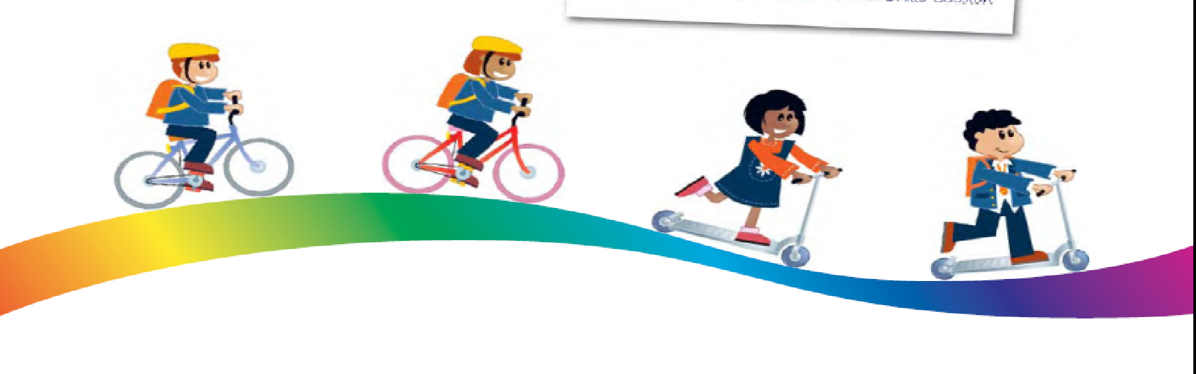

School Details

School name: Adswood Primary School

School address: Garners Lane, Adswood, Stockport, Cheshire. SK3 8PQ

Lead STP contact name: Mrs M Smart

Contact numbers: 0161 483 5003

Contact email if available: headteacher@adswood-pri.stockport.sch.uk

DFE reference number: 3562000
Contents

- About the school

- Location of the school

- Map of the area

- What is our travel plan?

- Aims of the Travel Plan

- Consultation with the school and community
- Problems identified in last School Travel Plan document

- Current in-school provision

- Children’s Hands Up Survey Analysis

- 2023 Objectives and targets

- Action Plan 2023-2024

Monitoring & Reviewing Our Plan

About the School

Adswood Primary is a 1.5 form entry primary school in the heart of a community.

The school has a higher proportion of pupils (52%) benefiting from free school meals than schools nationally (14%).
The numbers of SEND children in the school (23.3%) is higher than the national average (12.64%).
The school has 40% of pupils eligible for Pupil Premium.
The school attendance figure is below national average.

There are 325 pupils (Nursery to Year 6) and 58 members of staff.

We encourage walking, cycling and scooting to school and offering safer cycle training in Year 4 and 5 led by the LA. We offer a wide range of initiatives to raise awareness of road safety across the school, e.g. Operation Eagle Eye and Walk to School weeks along with ongoing campaigns throughout the school year promote the healthy lifestyle choice of walking to school.
The school recently took part in the School Streets Scheme which involved the closure of Neston Grove to allow for more families to walk and encourage a healthier lifestyle. (Summer 2022)
The school operates a Breakfast Club from 7.45am each weekday in term time and a number of After School Clubs.
There is a pelican crossing outside of the school on Garners Lane.

Parents/carers must drop off and collect their child each day from school unless they are in Year 6 where consent is given by parents/carers to allow their child to walk home alone.
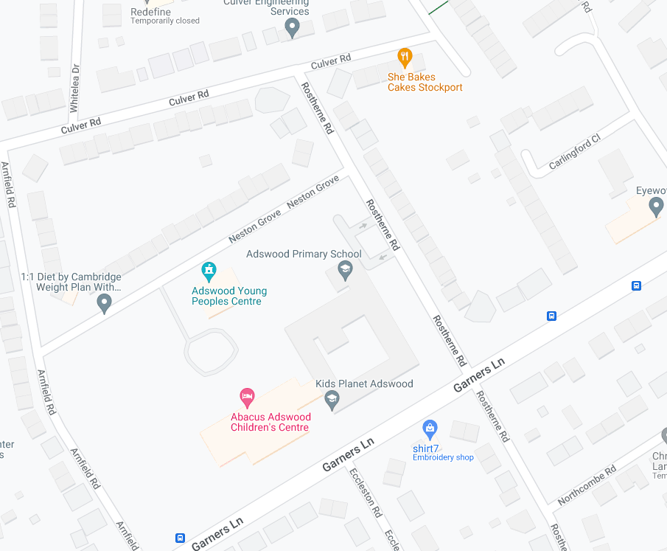

Location of the school

The school is situated in a residential area, which is surrounded by several busy roads such as Garners Lane and Adswood Road.

St Ambrose Primary school is situated only 0.5 mile away from the school.

There are no manned crossing patrols operating at the beginning and end of the school day. There is only one pedestrian crossing on Garners Lane.

Parking around the school is limited. Although a large percentage of children walk to school, parking in the immediate vicinity of the school can be problematic at the beginning and at the end of the school day and at times when meetings take place through the school day.

The number of car parking spaces is 16. Access is restricted to school staff and visitors. The gates are locked from 8:30am to 3:30pm.
The school is situated along a residential road and this area is often congested with residents’ parked cars making vehicle access difficult at times. Significantly, the increased traffic at the beginning and end of the school day creates a greater potential risk for many of our pupils and their parents and carers who walk to and from school. There is a clearly defined pedestrian entrance and subsequent route into the school and grounds at the main entrance. Since Covid 2020, the school uses the entrance on Neston Grove as access for pupils at the beginning and end of the school day. This allows for more space onto a larger playground ensuring safety for all.
There is no park and ride facility.
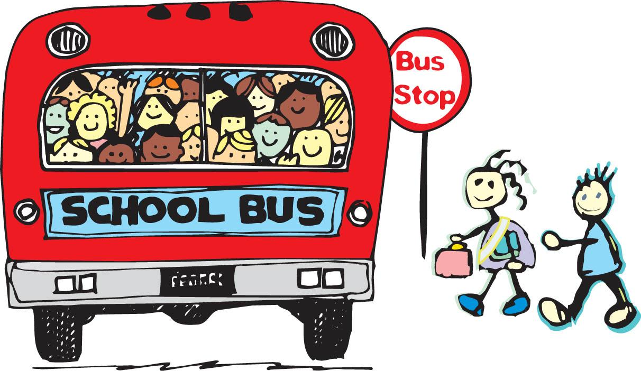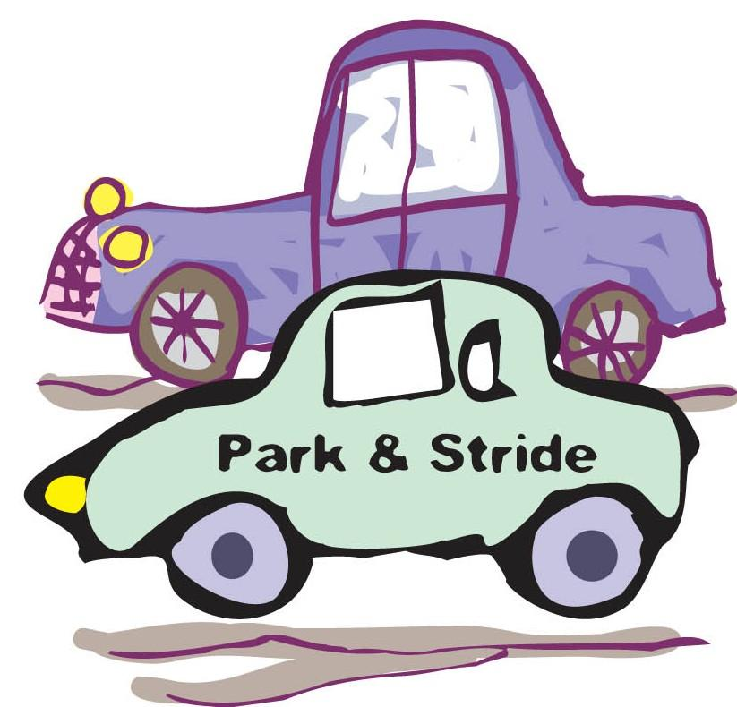

Aims of the Travel Plan
The overall aim of our Travel Plan is to improve road safety awareness of both parents and pupils along with improving health by promoting exercise. The Travel Plan aims to reduce congestion on roads from the ‘school run’ traffic, ease the conflict between vehicles and pedestrians and reduce parking problems around school. It aims to:
- Promote fitness and a healthier lifestyle by encouraging walking, cycling and scooting and so discourage car use.
- Maintain the high walking rates to school.
- Encourage more children to cycle and scoot to school.
- To improve road safety awareness for pedestrians particularly in the area around the entrance to the school car park.
- Encouraging pupils to have consideration for others by raising awareness of the borough’s traffic problems and supporting SMBC’s ‘cleaner, greener, safer, stronger’.
- Involving pupils and parents to make them feel part of the community.

Consultation with the school and community
In developing our Travel Plan, we have consulted with a wide body of interested parties:
- Children were involved in the “Hands Up” survey in the classroom and assembly.
- Consultations have taken place with the Headteacher and the Senior Leadership Team for their views on the Travel Plan and ways of making the pupils’ journeys safer.
- The Governors discussed the contents of the Travel Plan as part of their full Governing Body meeting.
- Discussions were initiated with the Local Authority Network Manager and the School for help and advice in revising the Travel Plan.
- Children were approached for their views on road safety around school.
- The plan has been discussed at a staff meeting.

Current in-school provision

- Weekly swimming for KS2 children on a rota

- Participation in Healthy Schools Programme - ongoing

- SSP membership – participation in school team sports tournaments

- Annual Bikeability training with Year 4 and Year 5

- Early Years road safety activities

- Step Outside initiative for Year 2

- Crashed Vehicle Project – Year 5

- Speed watch – Year 6

- Participation in Operation Eagle Eye

- Participation in SMBC Walk to School Week in October and March.

- Annual Infants and Juniors Sports Day’s

- PHSE activities – Keeping ourselves safe

- Road marking restrictions directly outside school (zig zags) to prohibit parking

- Ongoing police contact to ensure continued visits from traffic wardens to enforce parking restrictions on neighbouring roads.

- Regular communication on Seesaw about traffic parking

- Purchase of additional balance bikes in the Early Years

- Previous School Street Project - June 2022

Children’s Hands Up Survey Analysis

Date: 27th May 2022
Number of Pupils at School: 351
Mode of travel | Number of pupils | % of school
Car | 60 | 17%
Walk | 244 | 70%
Cycle/Scoot | 14 | 4%
Bus | 3 | 1%
Train | 0 | 0%
Pupils Absent | 29 | 8%

The last survey was carried out in May 2022 and reflects the results on this day alone.

The children were asked how they travelled to and from school, and how they would ideally like to travel, given the choice:

- 70%of children walked to and from school on this day
- There is a minority of 17% of children travelling to and from school by car/van
- 4% of children travelled by cycle

Following this another survey will take place in May 2023.

January 2023 Objectives and targets – to be reviewed termly

RED: No progress – target in danger of not being met

AMBER: Making steady progress towards target

GREEN: Targets met

Objectives | Targets | Action needed | When | Who
Reduce car use | Encourage walking to school | Continue to offer a wide range of incentives and activities to promote walking to school  Wide range of initiatives to promote safer cycling  Bike storage racks on exterior hall wall | Ongoing | Headteacher – whole school initiative  SBM /HT  HT/SBM  School Council  LA
Improve safety at school entrances | Monitor traffic on Road | Ongoing – communication with parents / carers continue to discourage drivers from parking outside school and from parking on zigzags  Cones to prevent cars from parking on the pavement.  Possible double yellow lines to stop parking  Termly visits from civil enforcement officers and PCSOs  Regular information sent on Seesaw  One way system introduced and continuously monitored  Parking on existing roads – monitor  Liaising with the traffic officers to consider walk way to replace one of the roads around school at key times | Jan 2023  ongoing | Headteacher  SBM  LA
Improved street safety measures for cyclists and pedestrians | Improve traffic signage.  Raise children’s awareness of road safety | Confirm with Council that signage is adequate  Practice walking in the street with KS1  Regular whole school assemblies on road safety  KS2 performance on road safety  FS road safety programme  Bikeability scheme  Transition programme | Summer 2023 | Street Environment /LA  Headteacher  PSHE Lead  Curriculum Lead

Action Plan 2022-2023

Objectives and Targets | Steps/actions needed | Timeline | Who is responsible?
Encouraging children and families to walk / cycle to school as part of overall Healthy School initiative | - Complete Traffic Survey with all pupils giving reasons for mode of transport. Results to form an appendix at the end of this travel plan.  - Keeping Ourselves Safe - PSHCE Scheme and Circle Time  - Planned walks in school time to encourage use of vicinity – local area and environment study etc. (curriculum review)  - Bikeability training for Y4/Y5 children – encourage general increase in cycling for health and leisure  - Practice walks in street for KS1 children – Road Safety Project KS1 | May 2023  Ongoing  Ongoing  Oct 2023  Oct 2023 | HT /SBM  Deputy Headteacher /AHT  PCSOs/ PSHE lead  Class teachers
Provide annual road safety training for all children | - Practice walks in street for KS1 children  - Source assembly material and performances  - Include in PSHE curriculum  - Increase children’s confidence in the street  - SMBC programmes eg. Crashed Vehicle Project | Oct 2023  ongoing | Curriculum Lead  Class teachers  PSHE Lead
Improve cleanliness of surrounding streets | - Contact the LA regarding dog waste  - Increase children’s awareness of associated health risks  - Increase signage.  - Children encouraged to keep school site clean – reduce litter/litter pickers  - Regular check of perimeter fences led by SBM and School Site Manager  - Eco-warrior groups to focus on litter on school field  - Community big clean up – school field focus | From January 2023 | PSHE Lead  SBM  A Bate  Site Manager

Monitoring & Reviewing Our Plan

- Our next hands up surveys will be: May 2023

- Our Annual Progress review will be completed in: January 2024

- Our full review of the School Travel Plan will be completed in: January 2025

- The person(s) responsible for ensuring the annual review will be done is the Headteacher

